|  |  |
| --- | --- |
| **Project:** | **Provisio** |
| **Course:** | **CSD 460 Capstone** |
| **Description:** | **Group 3**: Kyle Gotzman, Chee Her, Avery Owen,Jonathan Sudhop |
| **Date:** | **2022/9/18** |
| **Version:** | **0.1** |

**TABLE OF CONTENTS**

**Landing Page Test #1** 2

**Developer Test:** 3

**Landing Page Test #2** 6

**Developer Test** 7

**Login Page Test #1** 9

**Developer Test:** 10

**Login Page Test #2** 11

**Developer Test:** 12

**Registration Page Test #1** 13

**Developer Test:** 14

**Registration Page Test #2** 16

**Developer Test:** 17

|  |  |  |  |  |
| --- | --- | --- | --- | --- |
| Test 1 | **About Us/ Contact Us Page Test #1** | | | |
|  | **Test Objective:** Send a contact us message | **Developer:**  **Date tested:** 2022/9/18 | **Peer tester:**  **Date tested:** <yyyy/mm/dd> | |
| **Step** | **Action** | **Expected results:** | **Developer pass/fail** | **Tester pass/fail** |
| 1 | User starts at home page | User should land on the home page of the website | **Yes** | <yes/no> |
| 2 | Click on About Us Tab | User should be taken to the about us page | **Yes** | <yes/no> |
| 3 | Scroll down to see the contact us form | User should be able to fill out form | **Yes** | <yes/no> |
| **Comments** | **Developer Test:**  I have had troubles throughout when it comes to getting a lot of this project to run on my machine, so I am weary of what is wrong and what is just wrong on my machine. This seems to run great and the contact us form I think is a perfect size. Again, I think it has to do with the project being iffy on my machine, but I am unable to get the aboutus.png to load on the website. | | | |

## 

## 

## 

## 

|  |  |  |  |  |
| --- | --- | --- | --- | --- |
| Test 2 | **About Us/ Contact Us Page Test #1** | | | |
|  | **Test Objective:** Check to see if success page is shown after form completion | **Developer:**  **Date tested:** 2022/9/4 | **Peer tester:**  **Date tested:** <yyyy/mm/dd> | |
| **Step** | **Action** | **Expected results:** | **Developer pass/fail** | **Tester pass/fail** |
| 1 | User starts at home page | User should land on the home page of the website | **Yes** | <yes/no> |
| 2 | Click on About Us Tab | User should be taken to the about us page | **Yes** | <yes/no> |
| 3 | Scroll down to see the contact us form | User should be able to fill out form | **Yes** | <yes/no> |
| 4 | User clicks submit | User sees thank you message along with a link back to the home page | **Yes** | <yes/no> |
| **Comments** | **Developer Test:**  The contact us form works as expected. If there is one thing I would change, it would be the size of the ‘X’ used on the body of the contact form to clear the body. | | | |

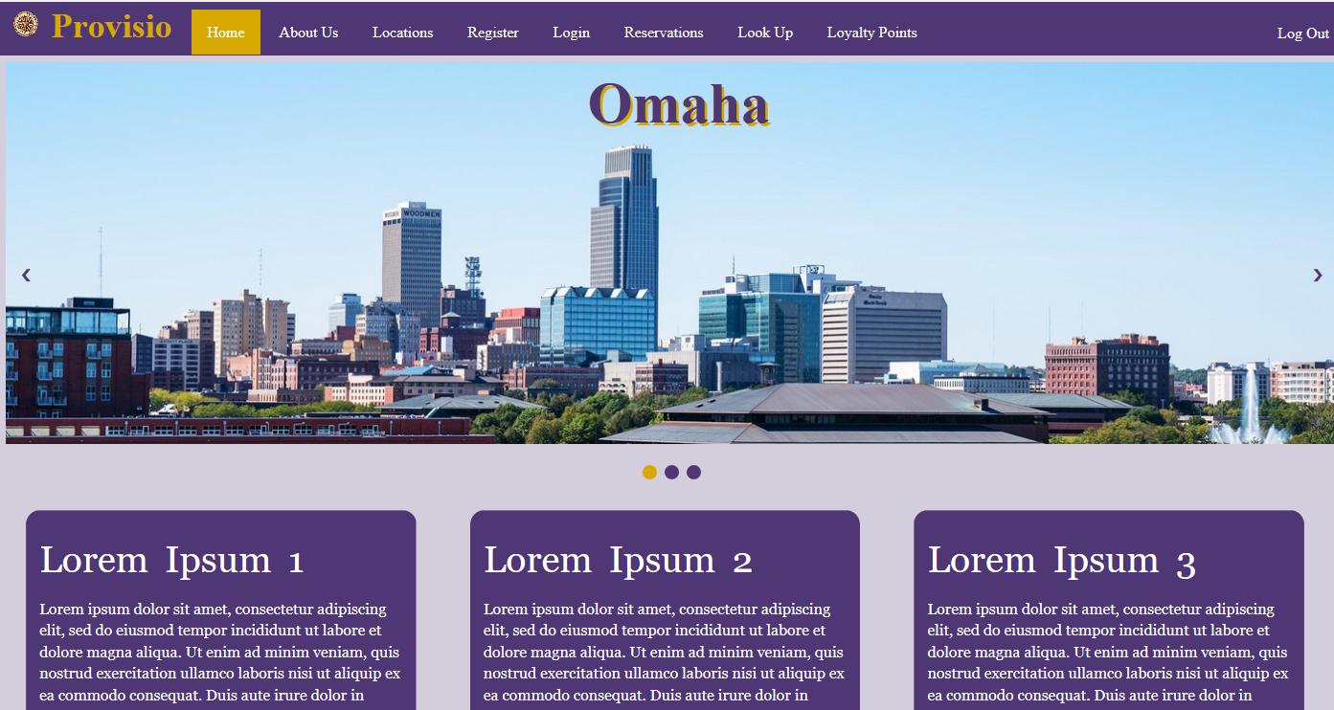

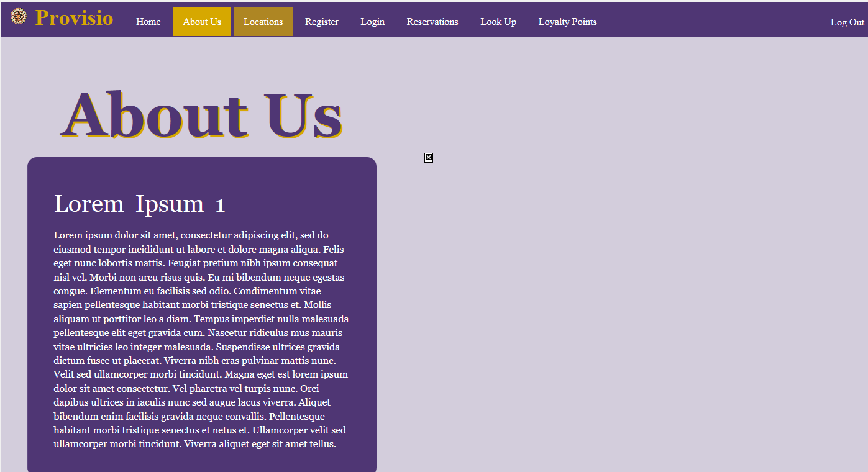

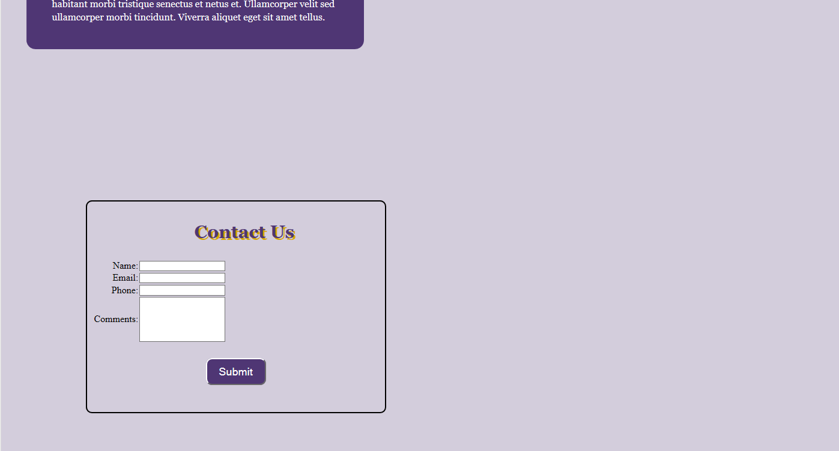

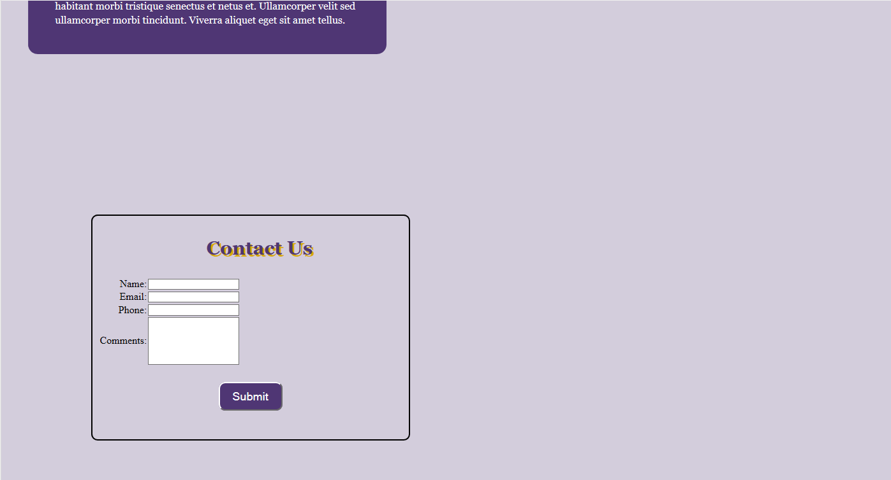

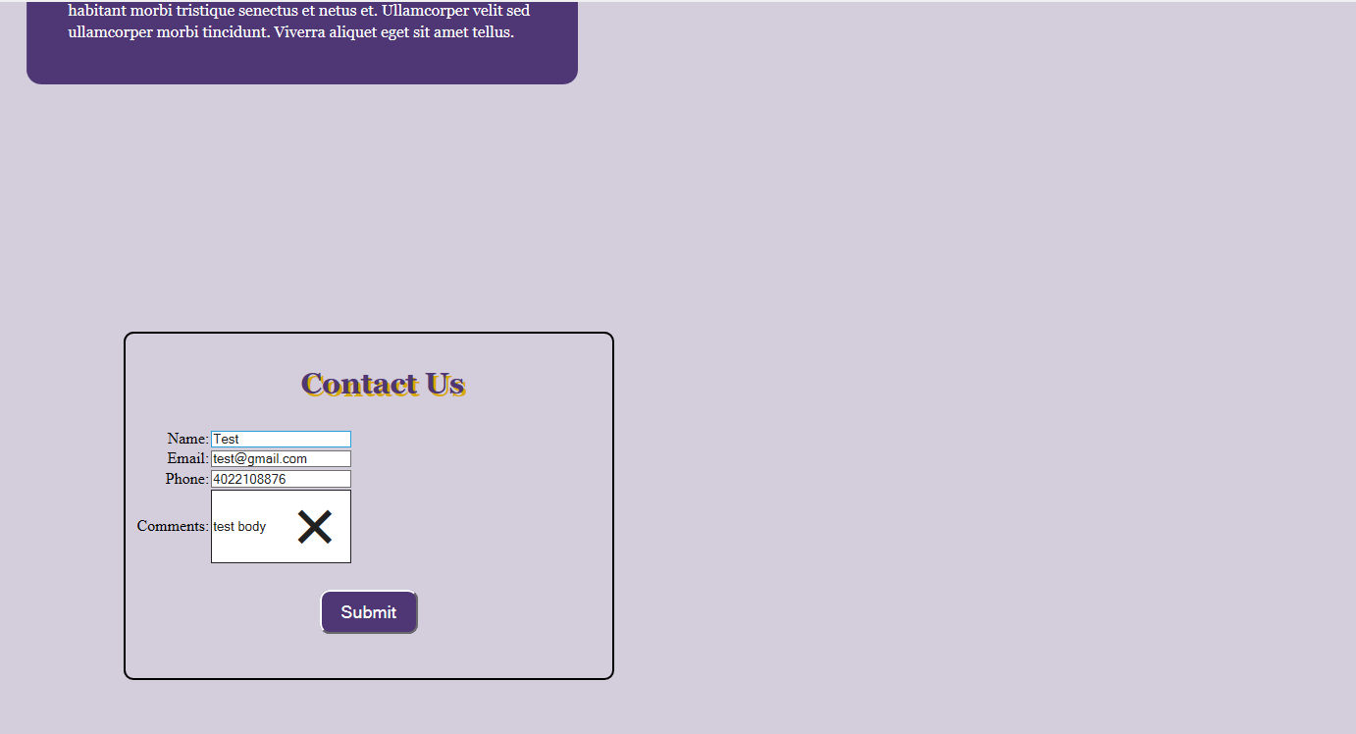

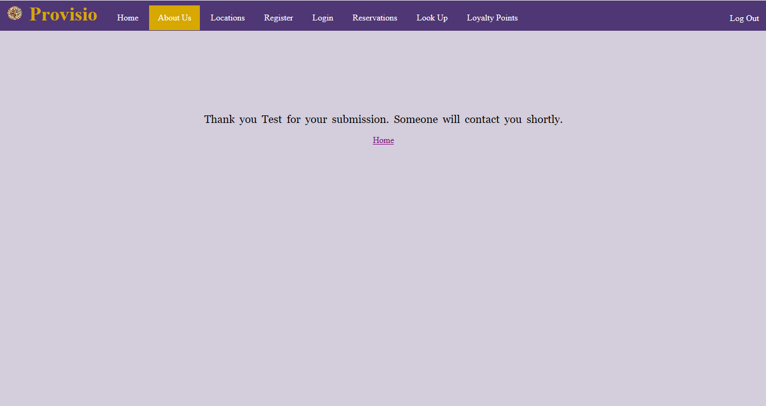

|  |  |  |  |  |
| --- | --- | --- | --- | --- |
| Test 3 | **Login Page Test #2** | | | |
|  | **Test Objective:** Contact Us Form not fully filled out | **Developer:**  **Date tested:** <yyyy/mm/dd> | **Peer tester:**  **Date tested:** <yyyy/mm/dd> | |
| **Step** | **Action** | **Expected results:** | **Developer pass/fail** | **Tester pass/fail** |
| 1 | Navigate to About us page | User should see the contact us form | **Yes** | <yes/no> |
| 2 | Click on the **contact form** | Text cursor should appear in textbox | **Yes** | <yes/no> |
| 3 | Click submit without putting in any text | Red outline and a requirement pop up appears | **Yes** | <yes/no> |
| 4 | Fill out name and email but not phone | Red outline and a requirement pop up appears only on phone | **Yes** | <yes/no> |
| **Comments** | **Developer Test:**  I really enjoyed this part of the contact us form. Making sure we are getting all information needed to know the customer and their credentials. My only thing I would add is making sure that they fill out the body of the contact form. As it is now, you are able to send blank messages as long as you fill out Name/Email/Phone | | | |





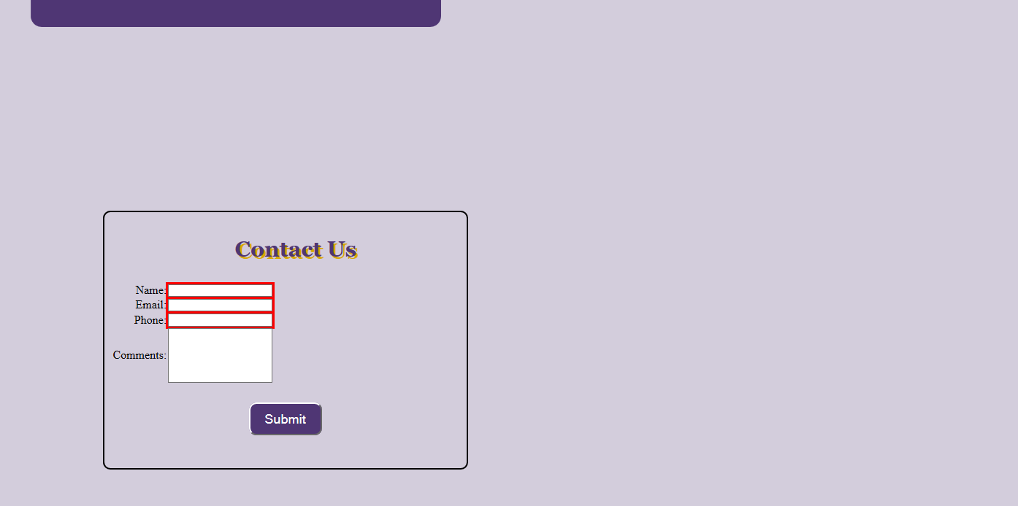

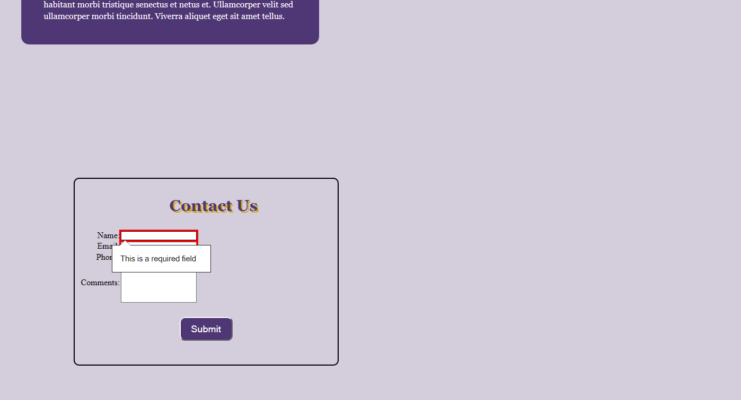

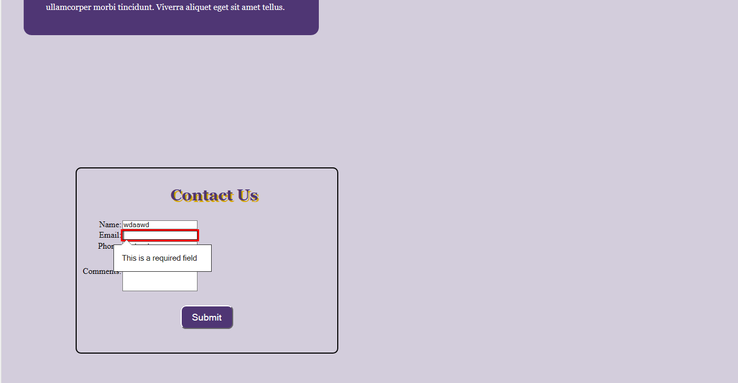

|  |  |  |  |  |
| --- | --- | --- | --- | --- |
| Test 4 | **Reservation Summary Page Test #1** | | | |
|  | **Test Objective:** Reservation Page is not visible if the user is not logged in | **Developer:**  **Date tested:** 2022/9/4 | **Peer tester:**  **Date tested:** <yyyy/mm/dd> | |
| **Step** | **Action** | **Expected results:** | **Developer pass/fail** | **Tester pass/fail** |
| 1 | Open home page | User should see the basic home page | **Yes** | <yes/no> |
| 2 | Click on the **Reservations tab** | User should get a page saying they need to log in | **Yes** | <yes/no> |
| **Comments** | **Developer Test:** | | | |



